Simple Login System - Code and Developer Challenge

Code Example: Simple Login System

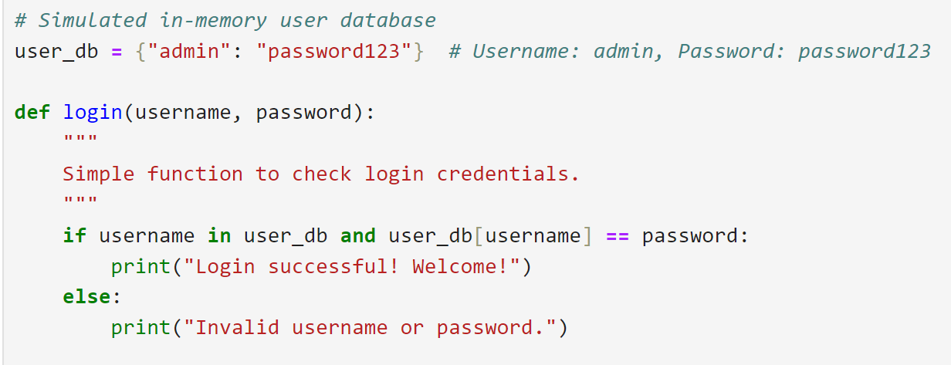
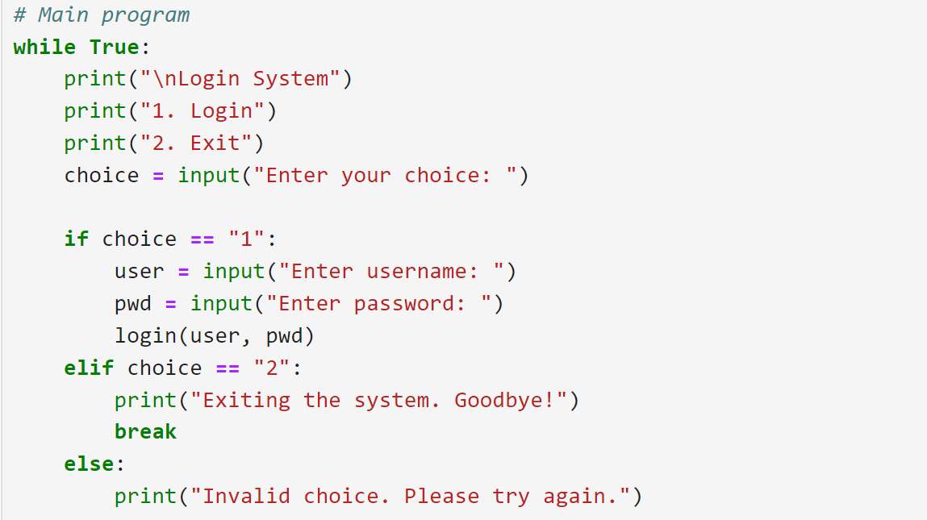

Developer Challenge
Developers are encouraged to analyze the following potential risks in this code and suggest improvements:
- Weak Password Storage: Passwords are stored in plain text. This is a significant security risk if the database is compromised.
- No Input Validation: The code does not check for input issues like SQL injection (if extended to a database) or excessively long inputs.
- Brute Force Attack Vulnerability: No limit on login attempts makes it vulnerable to brute force attacks.
- Hardcoded Credentials: The use of hardcoded usernames and passwords is a bad practice and should be avoided.
- No Secure Communication: Passwords are sent and compared in plain text, posing risks in real-world scenarios.

Developer Challenges
1. How would you improve the security of this login system?
2. Can you suggest a better way to store passwords securely?
3. How would you implement a feature to limit login attempts and protect against brute force attacks?
4. Would you handle user input differently to prevent potential vulnerabilities?

1. Improving the Security of the Login System
- Use Secure Authentication Libraries: Use established libraries like OAuth or OpenID Connect for handling user authentication.
- Implement HTTPS (HyperText Transfer Protocol) : Ensure all communication between the client and server is encrypted using HTTPS.
- Use Multi-Factor Authentication (MFA): Require additional authentication factors, such as a one-time passcode (OTP), for improved security.

2. Storing Passwords Securely
- Hash Passwords: Store hashed versions of passwords using a strong hashing algorithm like bcrypt, argon2, or PBKDF2.
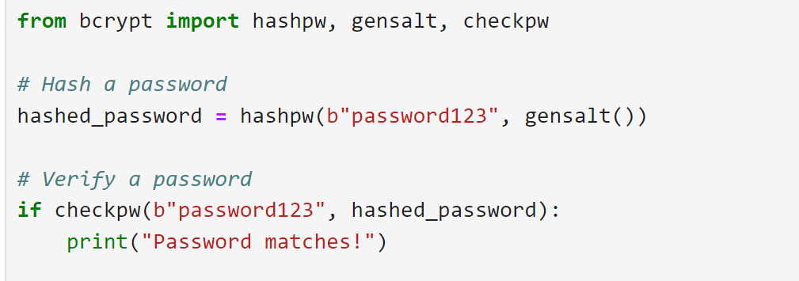

3. Implementing Login Attempt Limits to Prevent Brute Force Attacks
- Track Failed Attempts: Store the number of failed login attempts in the database or in-memory cache (e.g., Redis).
- Lock Accounts Temporarily: After a threshold of failed attempts (e.g., 5), lock the account for a duration (e.g., 15 minutes).
- Implement IP Blocking: Block requests from suspicious IP addresses after a certain number of failed attempts.
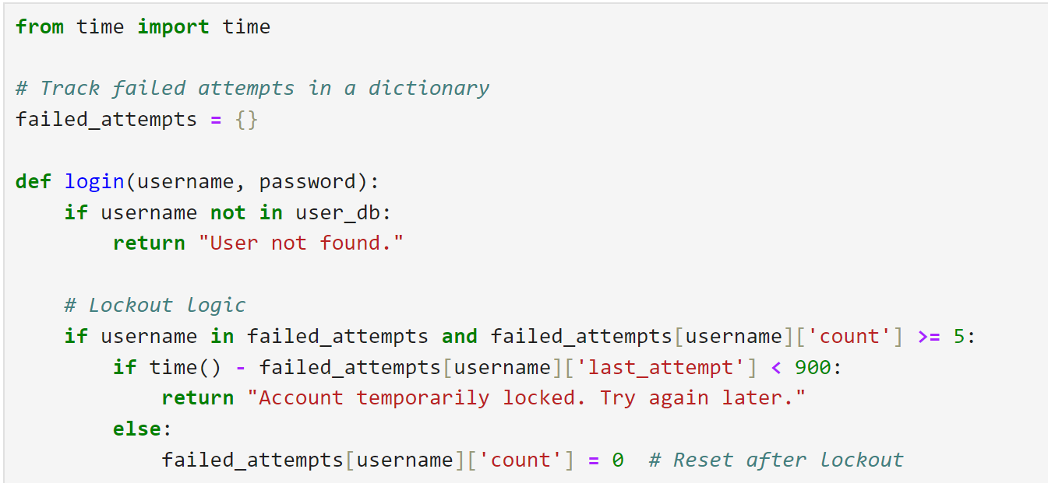
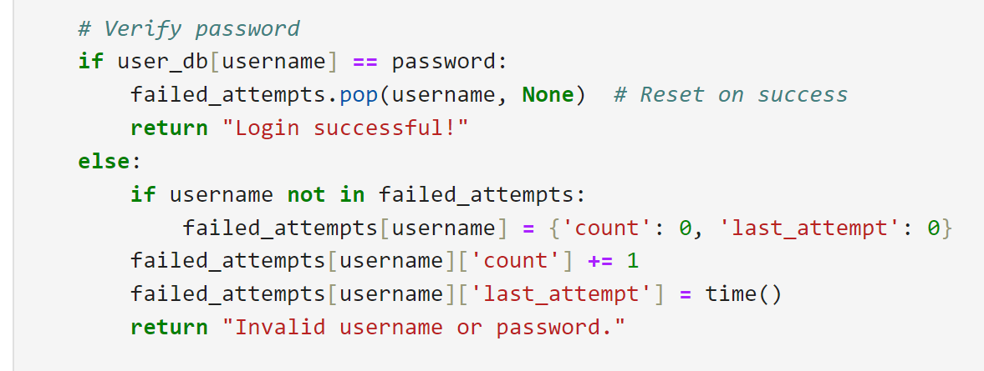

- Use CAPTCHAs (Completely Automated Public Turing test to tell Computers and Humans Apart): Add CAPTCHAs after repeated failed login attempts to prevent automated attacks.

4. Handling User Input to Prevent Vulnerabilities
- Sanitize Input: Use input validation to ensure only acceptable data is processed. For example, validate usernames and passwords for length and allowed characters.
- Avoid SQL Injection: Use parameterized queries or ORM tools like SQLAlchemy for database interactions.
